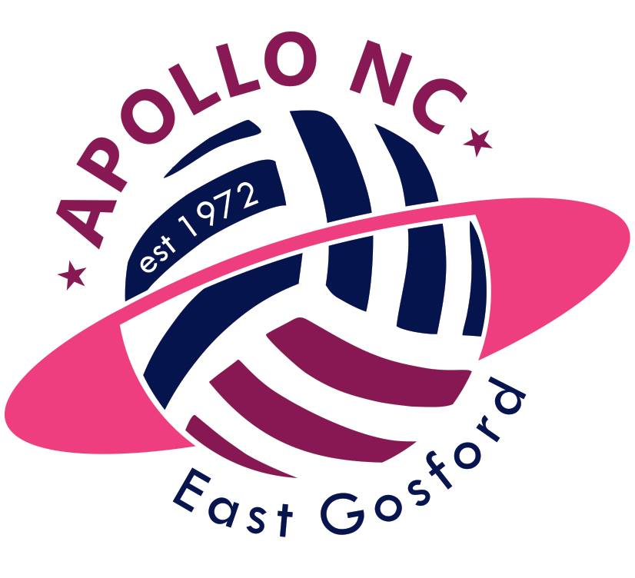
Apollo Netball Club East Gosford
Expressions of Interest – Division 1 – 2018 Season

Full Name* DOB*

Address*

Phone* (H) (M)

Email*

Parent/Guardian Name:

Playing History* grade/club/representative

2017:

2016:

Position 1* Position 2* Position 3:

*Required field
Qualifications:

It is an expectation of Apollo Netball Club that all members will help out where needed for the club to meet their obligations as part of Gosford Netball Association. For example: coaching, umpiring, attending GNA council meetings. Please indicate if you have any of the following qualifications:

Coaching:

Accreditation: Foundation/Development/Intermediate/Advanced

Year of Qualification:

Umpiring:

Theory Pass: Y/N Mark: Year:

Please select: White Award/Gosford Award/Nat C/Nat B/Nat A

Year of Qualification:

Please note:
- Players must be at least 15 years of age by the 31st December 2018 (as per GNA policy).
- An Expression of Interest (EOI) is not a registration form.
- Completion of an EOI will provide each player the opportunity to participate in skills and match trial (pending number of expressions of interest).
- Trials will be held early October. Confirmation of trial date will be provided.
- We are looking to form a single division 1 team for the 2018 season. For this reason registrations will be limited.
- Players will be notified of an offer of registration by 5pm, 18/10/17.
- All players completing an EOI will receive an email within 48 hours acknowledging receipt. If you have not received a confirmation email, please contact apollonetballclub@gmail.com

Your signature below indicates you have read and understand the above.

Player Name:

Player Signature:

Parent/Guardian Name:
(If under 18) f

Parent/Guardian Signature:
(If under 18) f

Date:

Please return your completed Expression of Interest to
apollonetballclub@gmail.com
By 5pm Friday September 15th 2017

